Task 3

1. Chat GPT

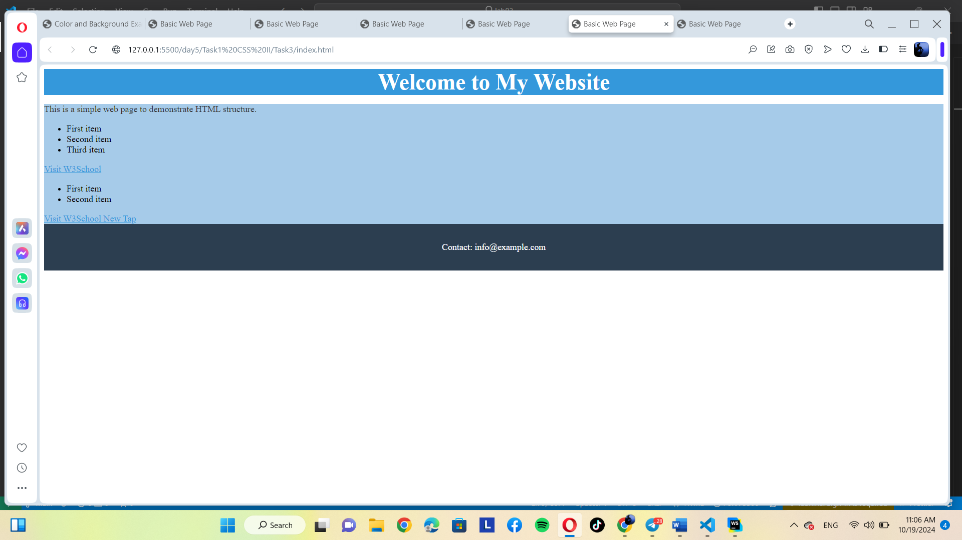

2. Gemini

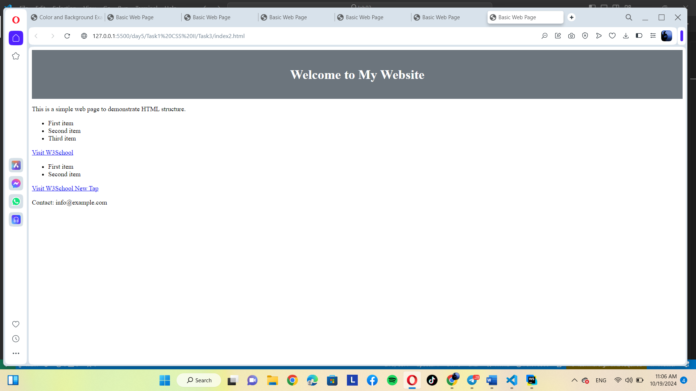

Both follow the prompt but Chat GPT is better